Assignment 4 – Group : SE-2006

Students: Zainiddin Tursunaliev, Esanjon Usmanov

**PART 1 – MEDIA QUERIES**

Task 1. Responsive Typography

1. Create a simple webpage with headings and paragraphs.
2. Use media queries to change font sizes for mobile, tablet, and desktop.  
   Example: small font on mobile, medium on tablet, larger on desktop.

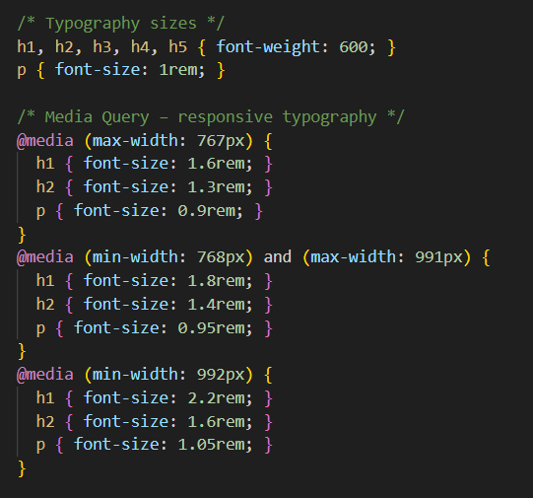

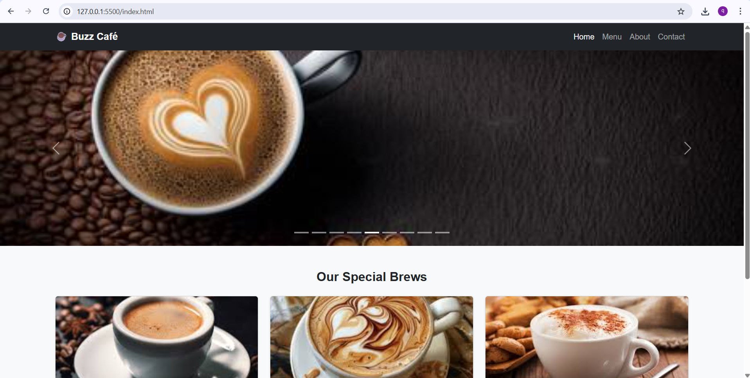

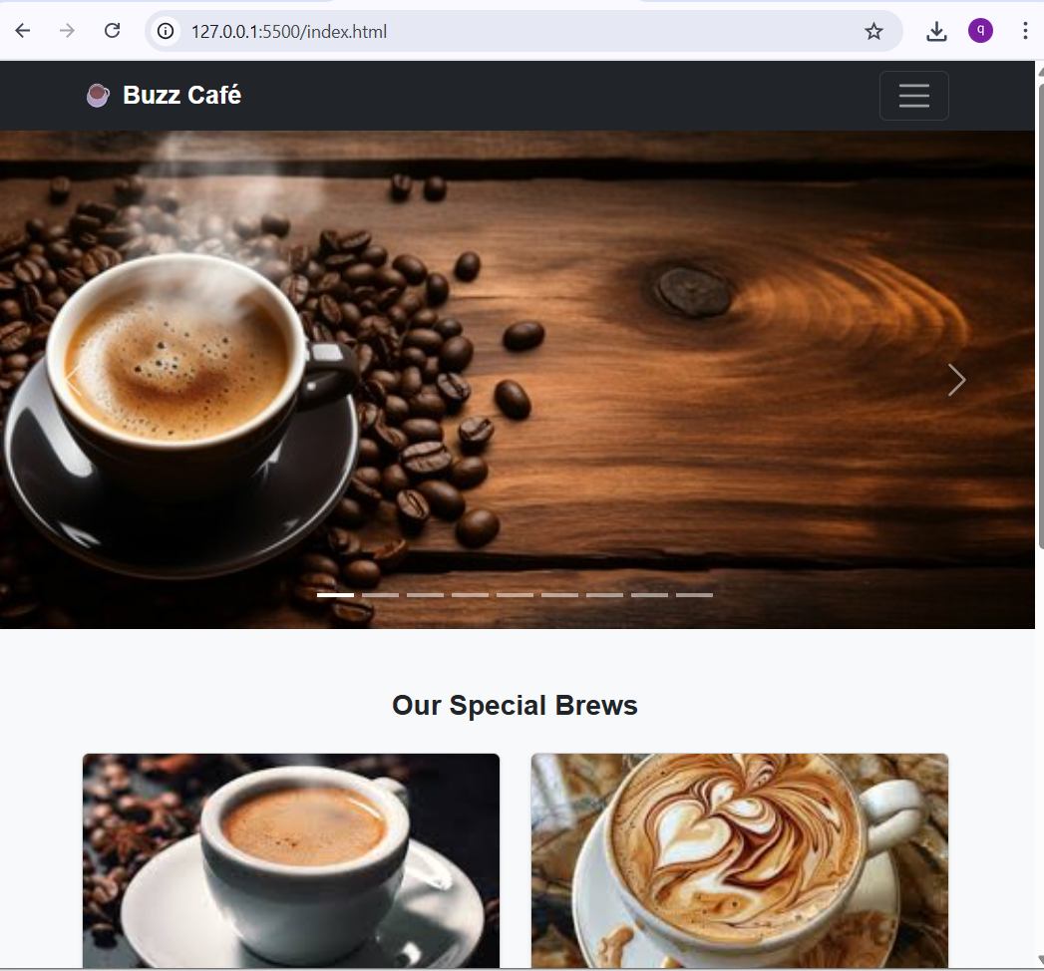

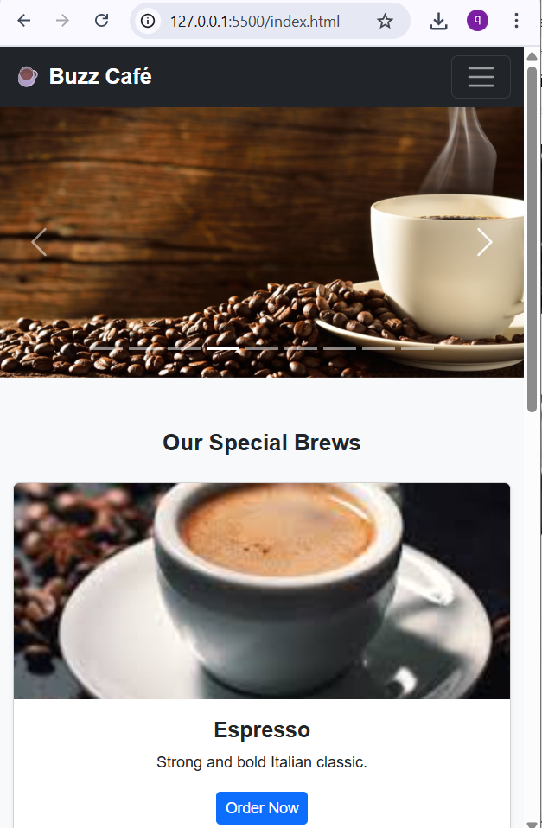

**Task 2. Card Group (CSS Media Queries only)**

1. Create a webpage with three cards in a row.
2. Use only CSS media queries (no Bootstrap).
   * On desktop: 3 side by side
   * On tablet: 2 per row
   * On mobile: stacked vertically

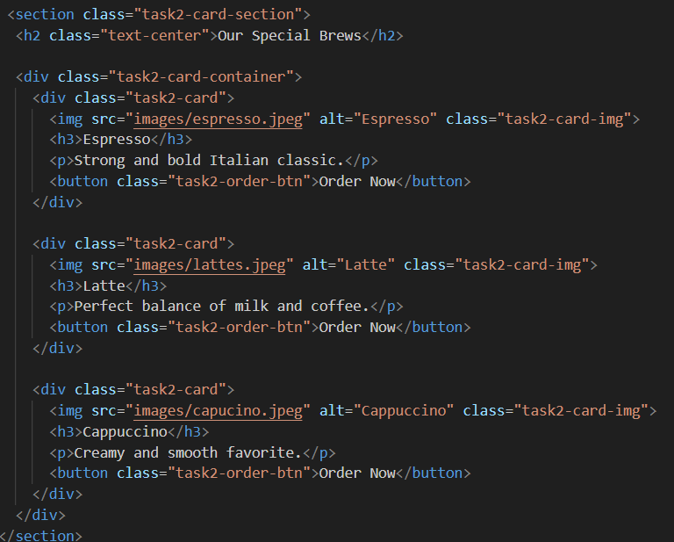

CSS section

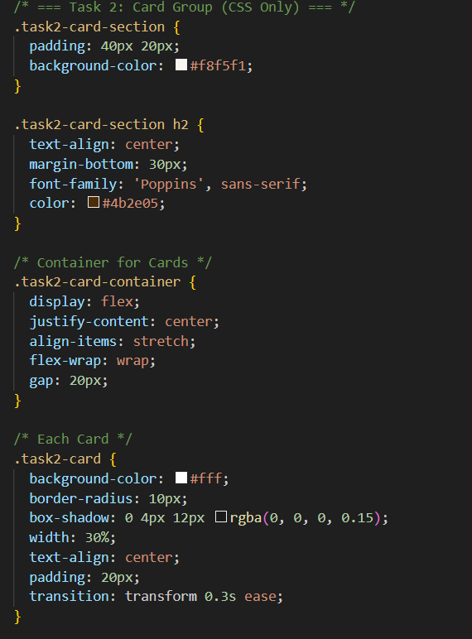

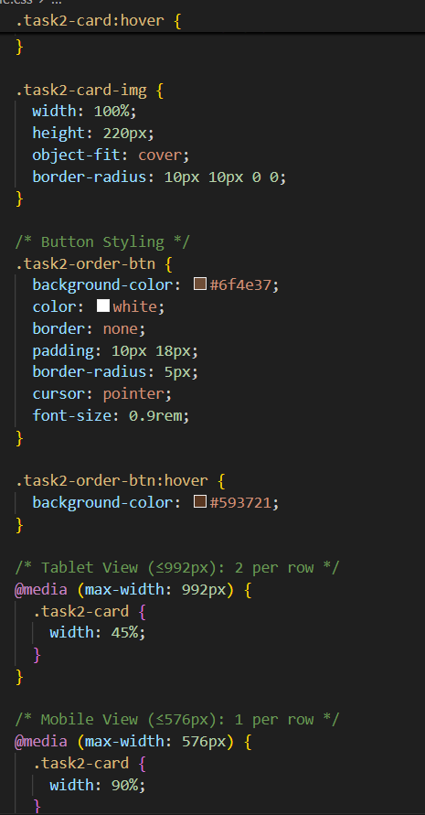

**Part 2. Bootstrap**

**Task 3. Bootstrap Grid Layout**

1. Replaced custom layouts with Bootstrap Grid (container, row, col-lg-*).
2. Created one two-column and one three-column section.

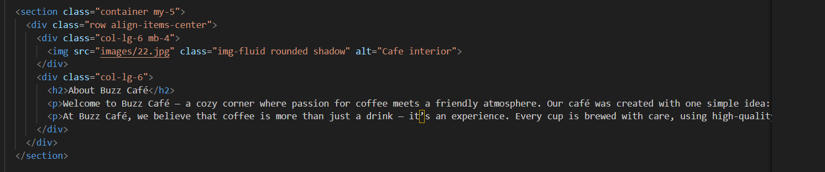

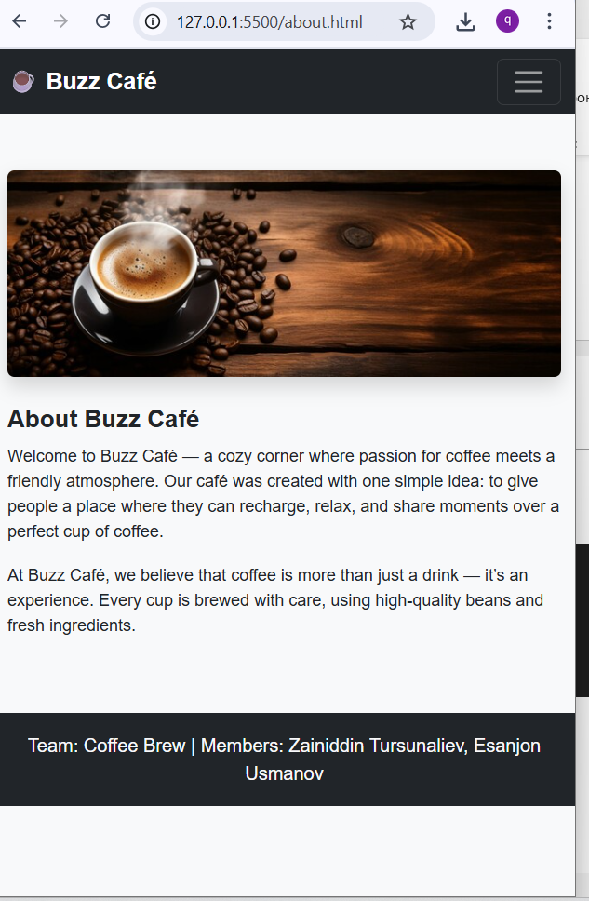

**Task 4. Bootstrap Spacing Utilities**

1. Replaced custom paddings/margins with Bootstrap classes (p-3, m-4, etc.).
2. Added responsive spacing (mt-lg-4, px-sm-2).

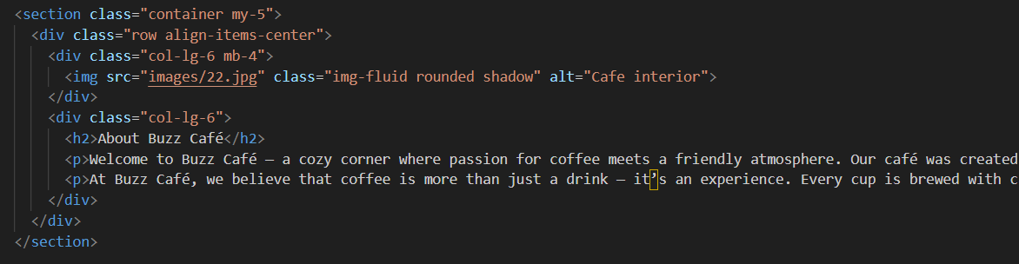

* my-5 → adds vertical spacing between sections.
* px-sm-3 px-md-5 → horizontal padding that adjusts with screen width.
* mb-4, mb-lg-0 → controls vertical spacing between columns.
* p-2 → adds light padding around the image for consistent

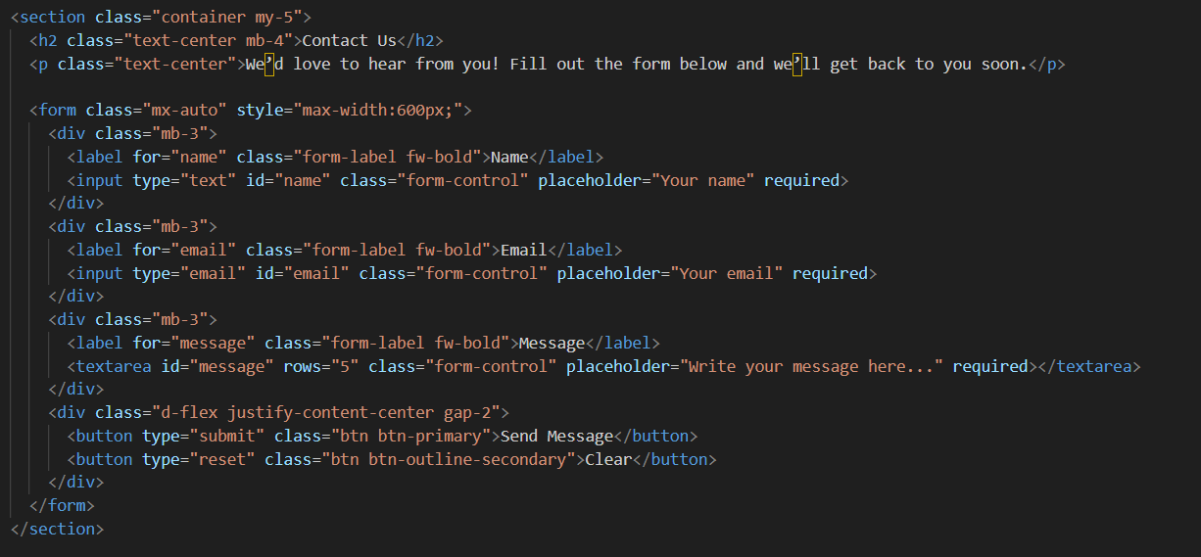

**Explanation:**

* my-5 py-4 → vertical spacing between this section and others.
* px-sm-3 px-lg-5 → responsive horizontal padding (narrower on mobile).
* bg-light rounded shadow-sm → soft background and elevation for clarity.
* mb-3 → consistent spacing between form fields.
* px-4 py-2 on button → uniform button padding.

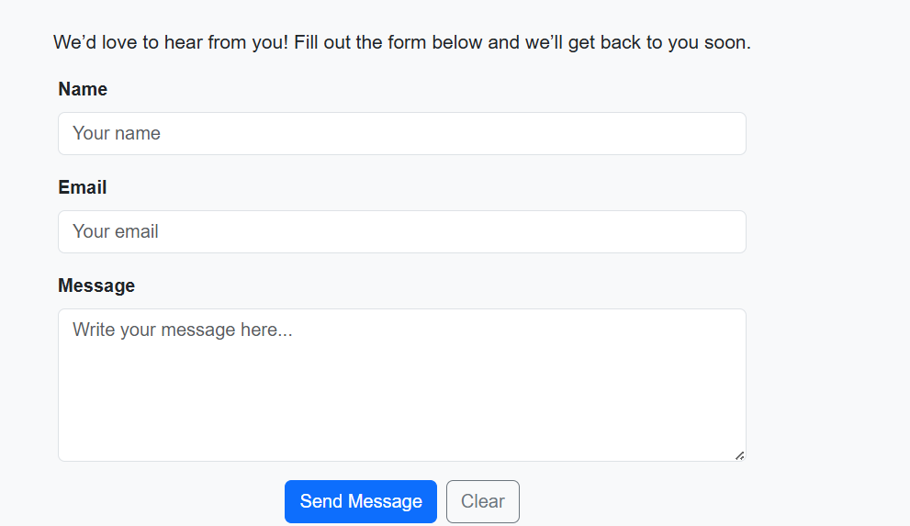

**Task 5. Bootstrap Navigation Bar**

1. Added a responsive Bootstrap navbar with collapse menu.
2. Customized colors and links.

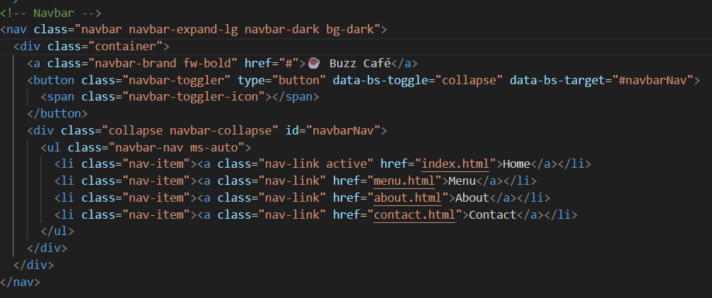



**Task 6. Bootstrap Buttons**

1. Replaced all buttons with Bootstrap buttons.
2. Added button group for related actions.

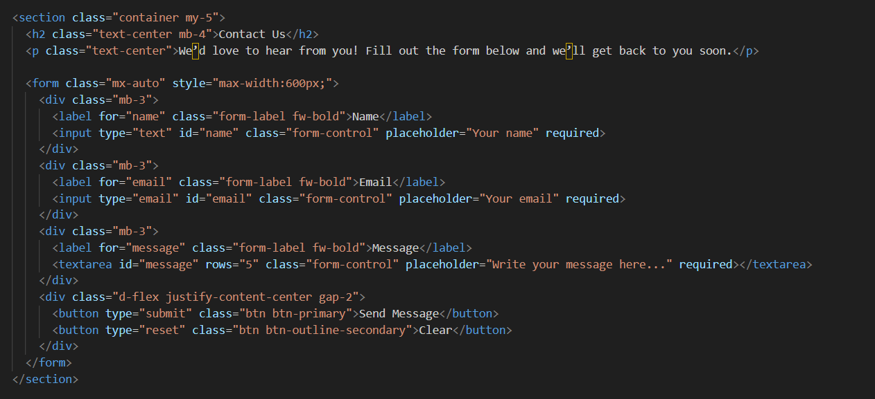

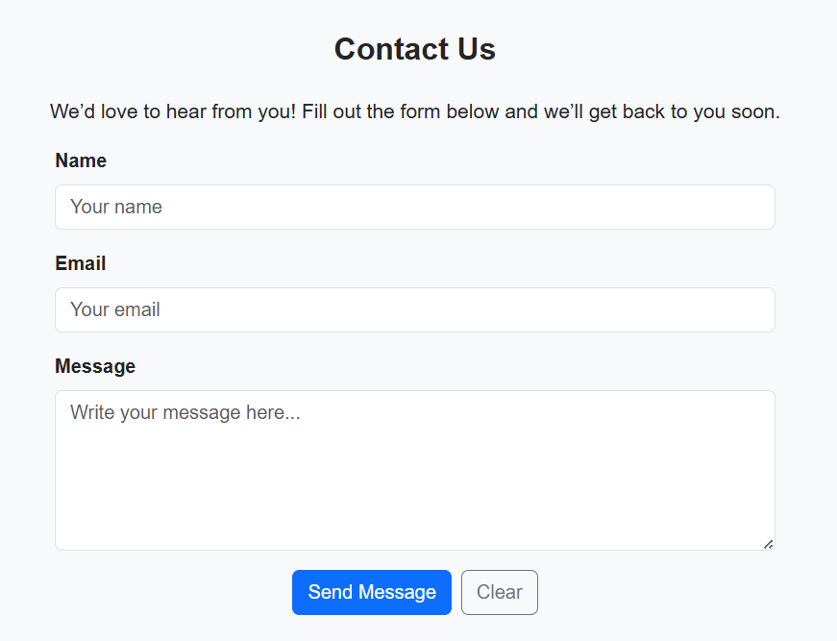

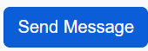

**Task 7. Bootstrap Carousel**

1. Added a 9-image carousel using menu item images.
2. Used .carousel-inner and .carousel-item for sliding effect.
3. Made all images same height using CSS.

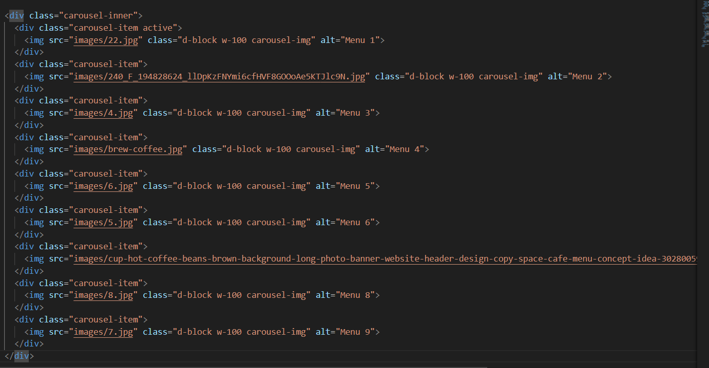

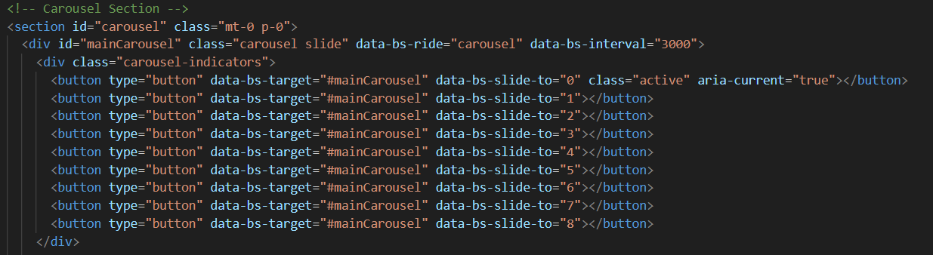

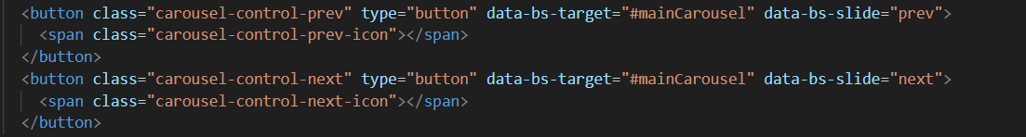





**Task 8. Bootstrap Cards**

1. Replaced custom cards with Bootstrap card group.

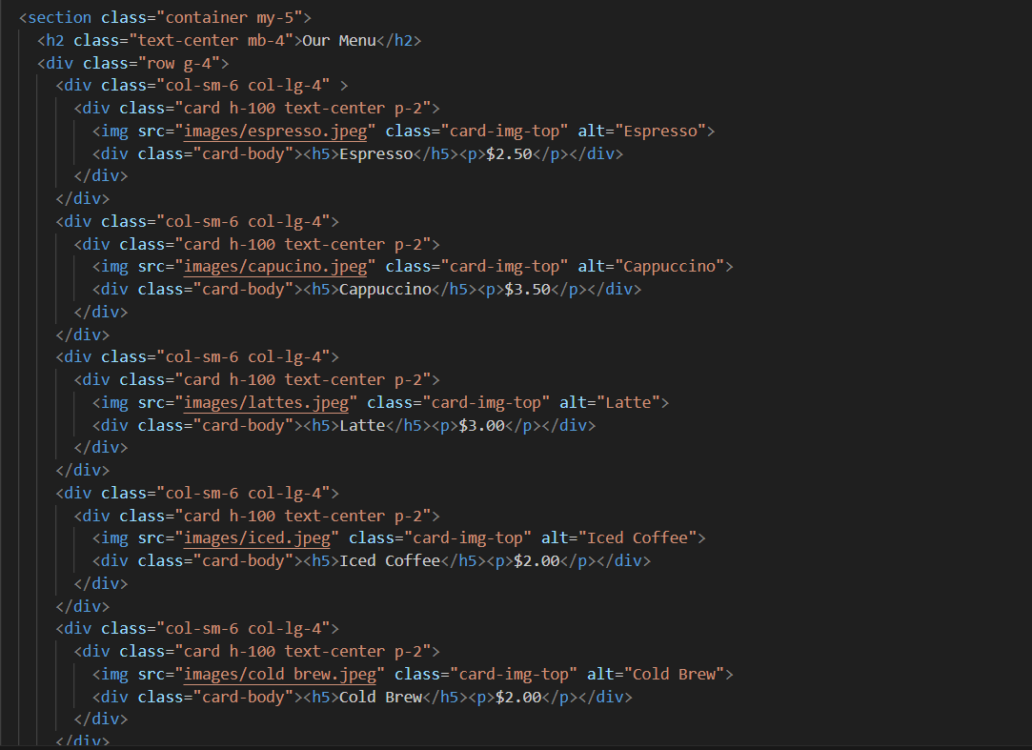

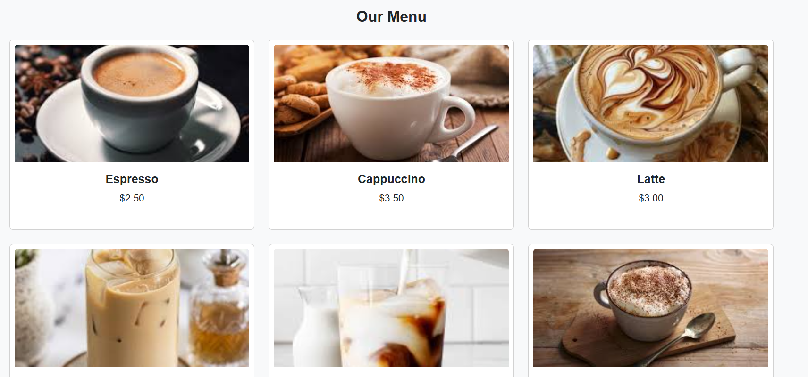

**Task 9. Responsive Form Design**

1. Styled contact form using Bootstrap’s form-control and grid.

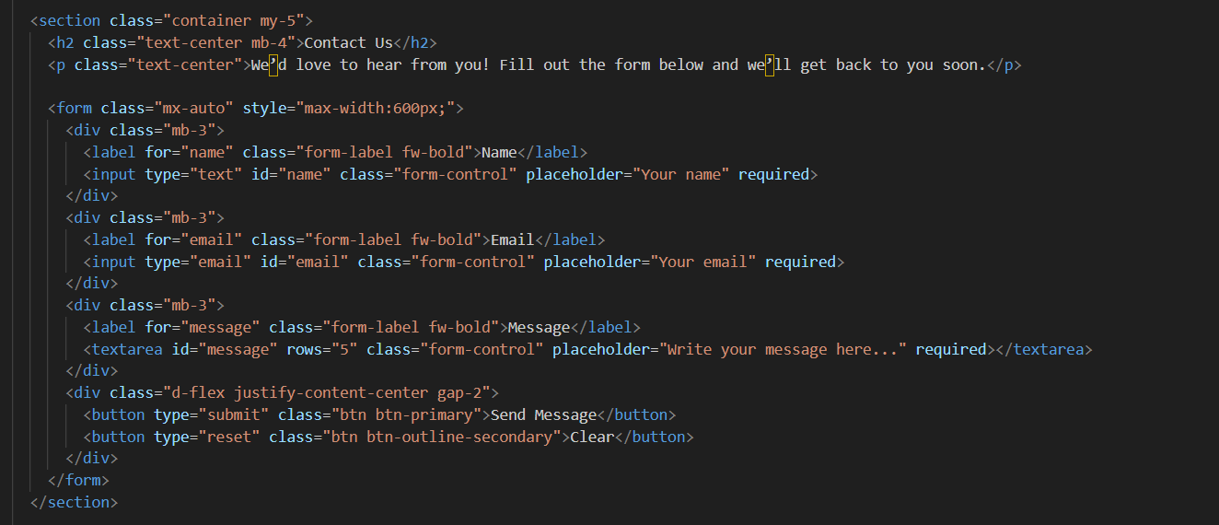

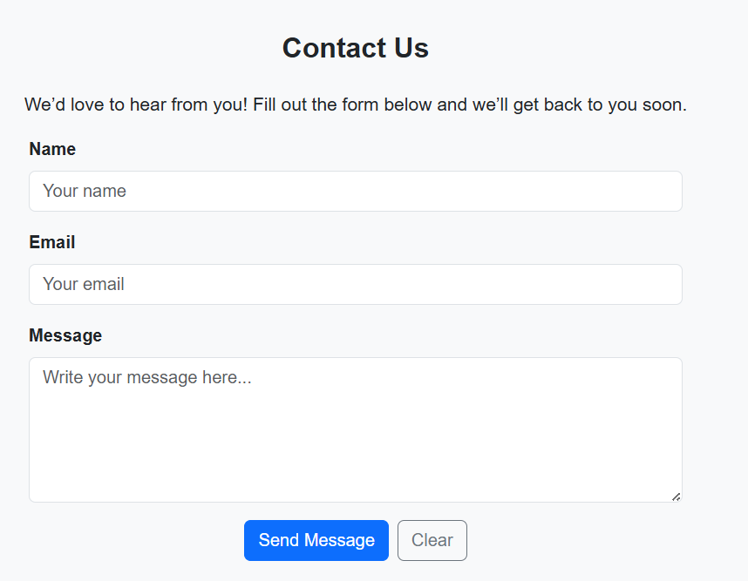

**Task 10. Accessibility**

1. Used semantic HTML elements (<nav>, <button>, <form>, etc.).
2. Checked contrast — light text on dark backgrounds.
3. Bootstrap components maintain readability and keyboard navigation support.



For connecting bootstrap

